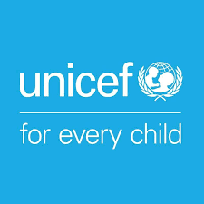

Easy to read

Our plan to include people with disabilities in all our work to make life better for children everywhere
2022 to 2030

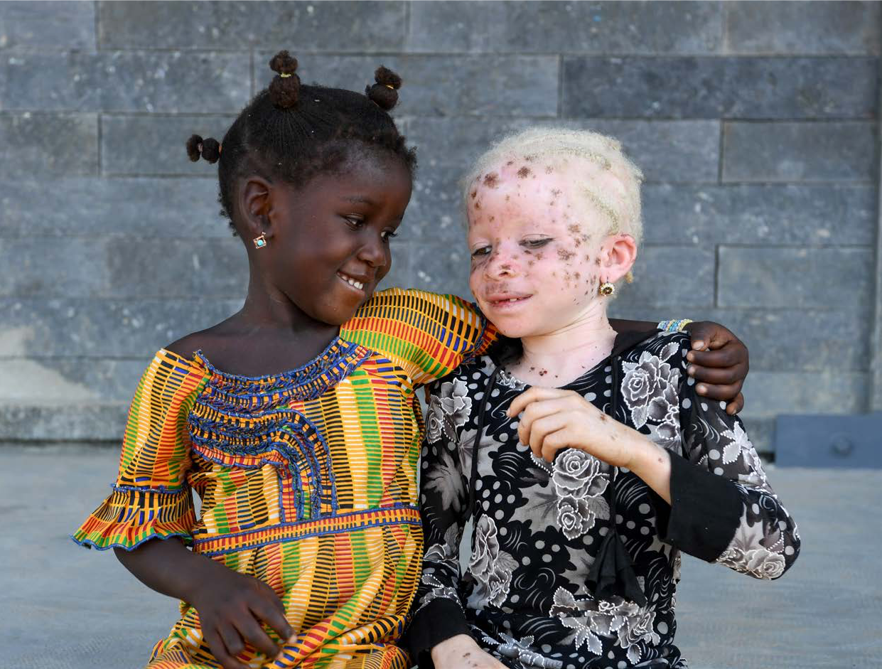

An easy read version of Unicef Disability Inclusion Policy and Strategy 2022 to 2030

About us

We are called Unicef.
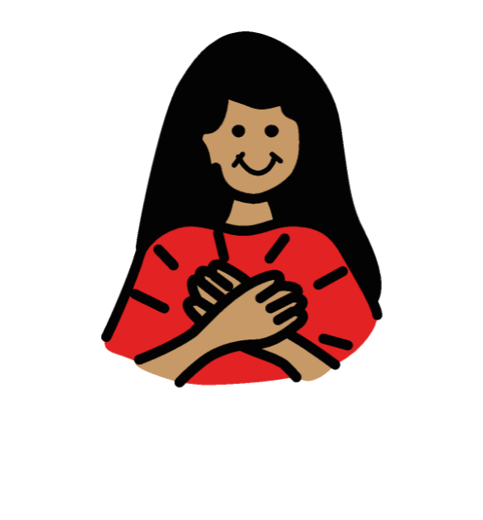

We work to make sure that all children in the world are safe and treated fairly.

We work in over 190 countries to do that.

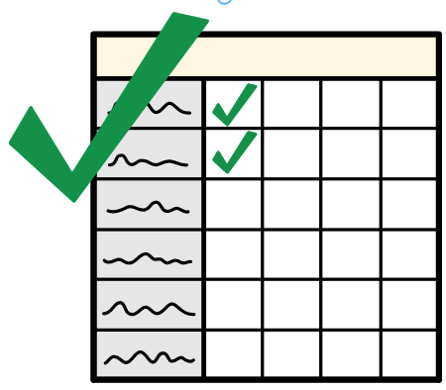

About this plan

This plan is called our
Disability Inclusion Policy and Strategy 2022 to 2030.

We call it DIPAS for short.

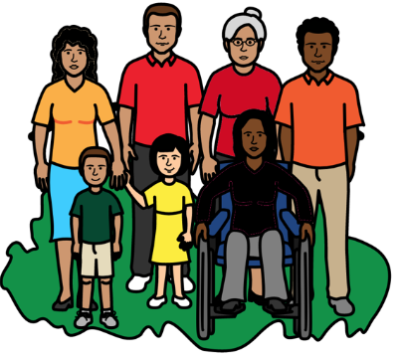

This plan is about what we will do to make sure that all children with disabilities can take part in the community like everyone else.

They should never be left out.
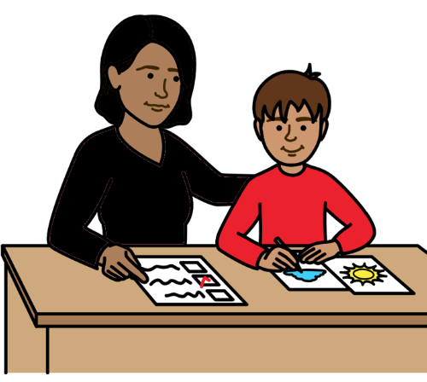
That means making sure that children with disabilities get all the support they need to have a good life.

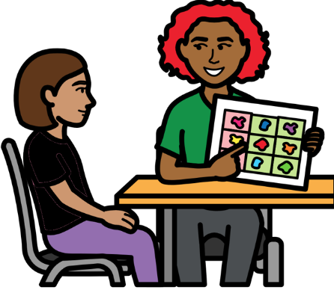

Support can mean many things, like:
- good health care and education.
- support to move around and communicate.
- support to speak up and have a say.

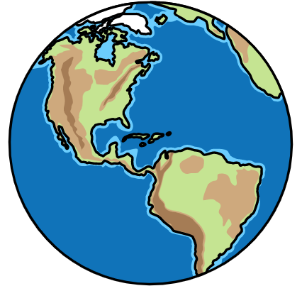

We want children with disabilities to be a big part of our work.

We work all over the world.

That means we can really help to change things for children with disabilities.
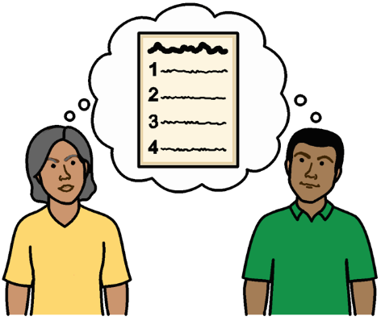

We have already started work to change things.

But this plan will help us to do more together.

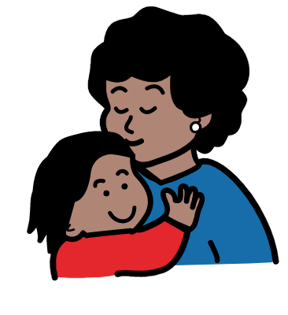
Why we need this plan

All children should be happy and safe.

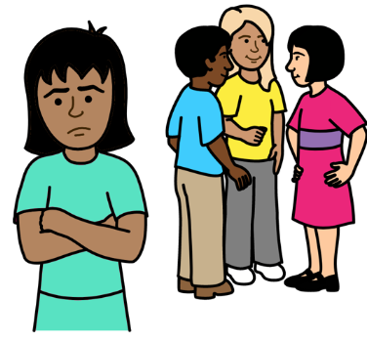

But that is not happening for many children with disabilities.

Children with disabilities are often left out and treated badly.

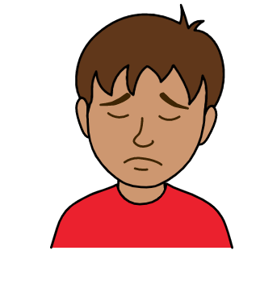

That makes many children with disabilities sad.

They do not have much hope for the future.

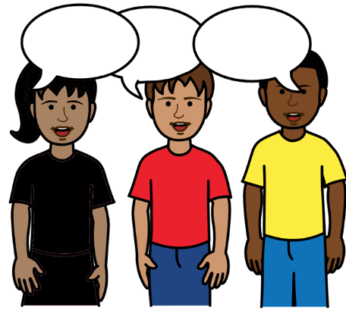
We must all work to change that.

How we made this plan

We worked with children and adults with disabilities, our staff and other people to help make this plan.

The 4 main things that we want to change for children with disabilities

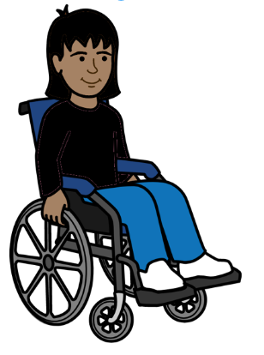
1
We want everyone to see that
children with disabilities are very important just like other children.

They should be listened to.

They should have a real say in what happens to them.

They can help to change things for all children with disabilities.

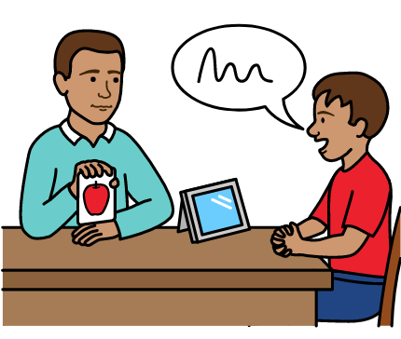
2
We want children with disabilities to get the support they need all through their lives.

That will help them to take part in everything.

It will help them to live the way they want to.
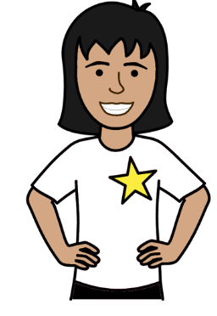
We want children with disabilities to have the same chances to do well as everyone else.
3

They should have everything they need to do well.

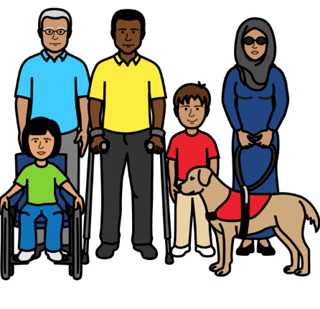

We want children and adults with disabilities to get good support from our work and projects.
4

They should not be left out.

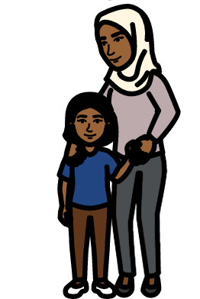

Some of the main things we will work on

We will help to make sure that all children with disabilities are safe and treated fairly.

We want to stop children with disabilities being hurt or left out.

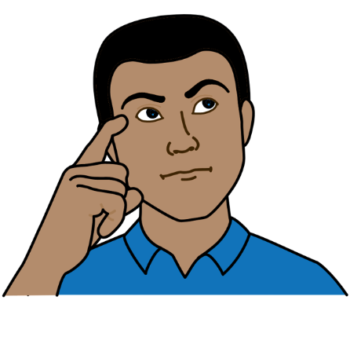
We will help to change the way that people think about children with disabilities.

That includes people who make big decisions for the country.

We will help people to see why it is important to include children with disabilities and treat them fairly.

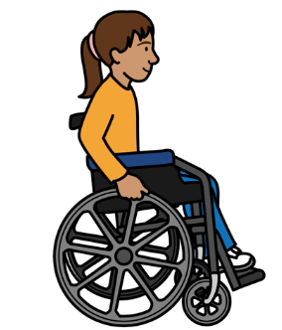
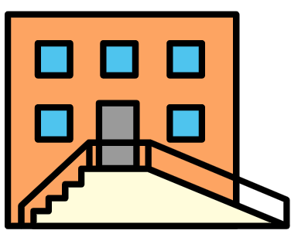
We will work to make things easy for people with disabilities to use and take part in.

That includes transport, buildings, information, support and work places.

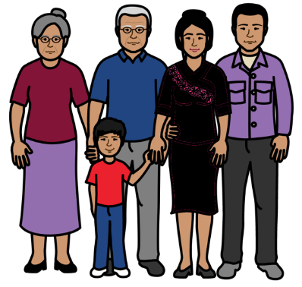

We will work to make sure that children with disabilities can get all the support they need near where they live.

That means near their family and friends.

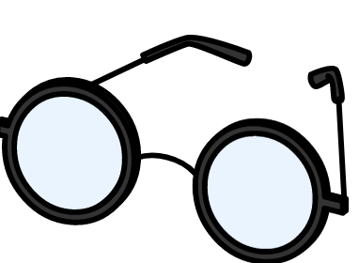
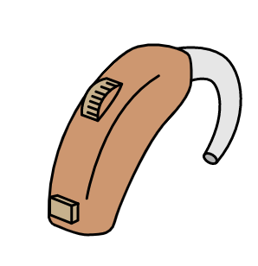
We will help more children with disabilities to get the equipment they need to take part in things.

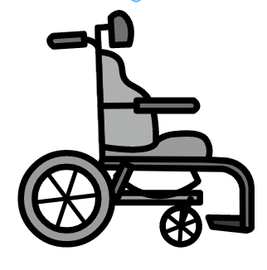
Equipment could be many things like:
- Wheelchairs.
- Hearing aids.
- Glasses.
- Things to help children communicate.

We already get lots of equipment for children with disabilities.
But we want to get more.
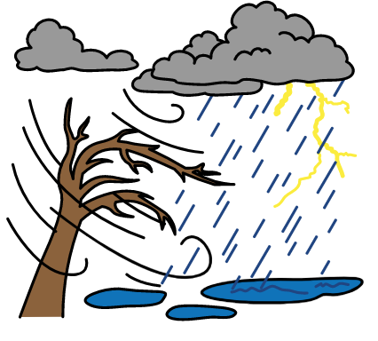

We will help to make sure that children with disabilities get the right support when there are big problems in the country.

Like war, floods or not enough food.
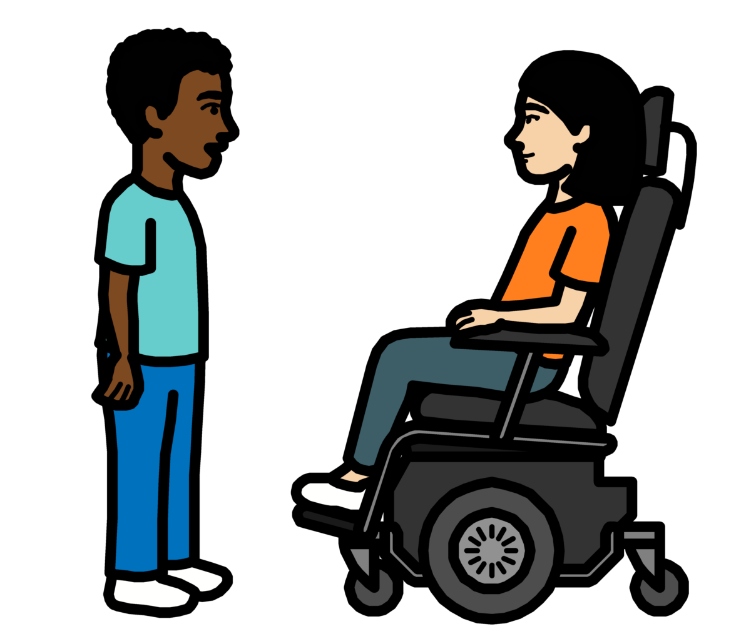

We will support children and adults with disabilities to have a big say in decisions about their lives and their countries.

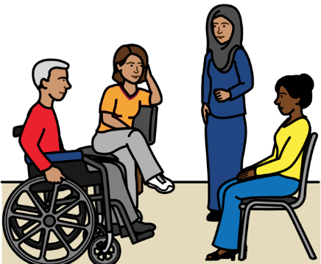
Some things that will help us with this plan

We will work with many other people and organizations on this plan.

That includes people with disabilities who work with Unicef.
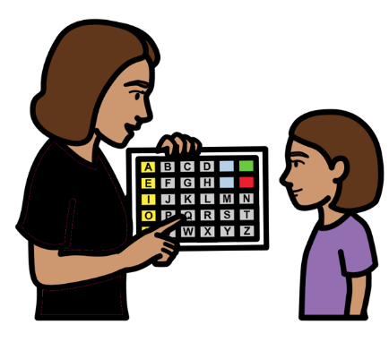

We will work with organizations that help us to give people support.

We will help them to work in a better way with children with disabilities.

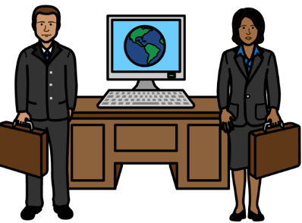
We will work with people who make big decisions for the country.

We will also work with companies.

We will help them to give people with disabilities better support and more chances to do well.

That includes making laws and rules that work well for people with disabilities.
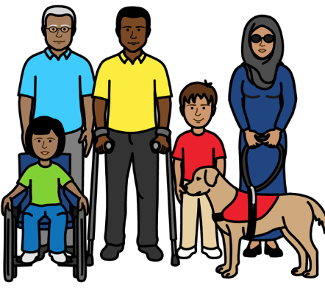
We will include people with disabilities in our projects and plans for everyone.

But we will make some projects and plans just for people with disabilities if we need to.

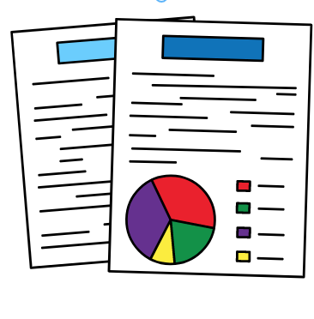

We will keep finding out good information about people with disabilities and their lives.

That will help us to know what people with disabilities need
and how things are working for them.

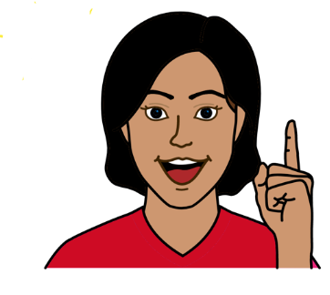

We will look at new ideas to make life better for children with disabilities.

For example, we will look at new ways to find out what children with disabilities want and need.

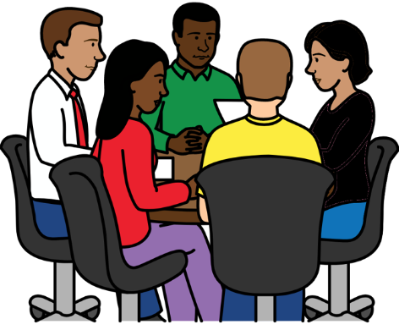
We will work more together with different parts of our organization.

That will help us to look at everything we need to do for children with disabilities.

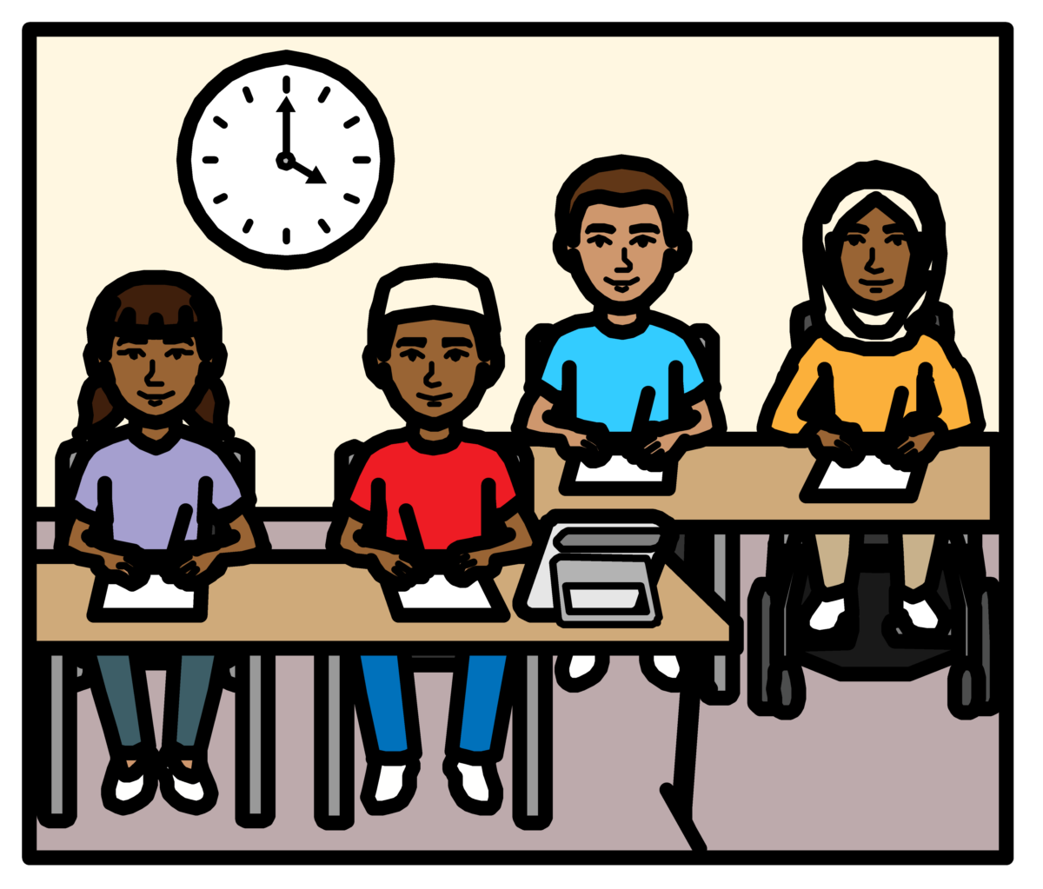

For example, we might work to make a school better for children with disabilities.

We must look at everything that children with disabilities need to go to that school.
For example:
- Transport that is easy to use.

- School buildings and toilets that work well for children with disabilities.

- Money and support for families to help their children to go to school.

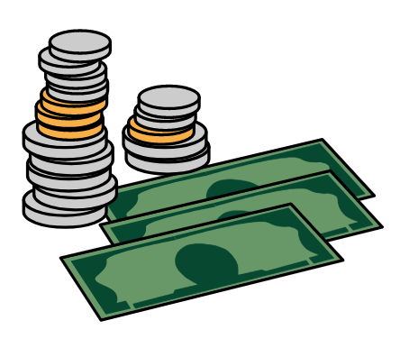
We will spend more of our money to make this plan happen.

And we will work to get more money from other places for this plan.

We are changing the way we work.
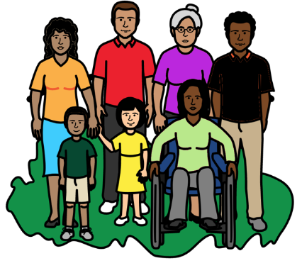

We want to work in the best way we can to include people with disabilities.

That means children with disabilities and our staff with disabilities.

We have a new team of people.
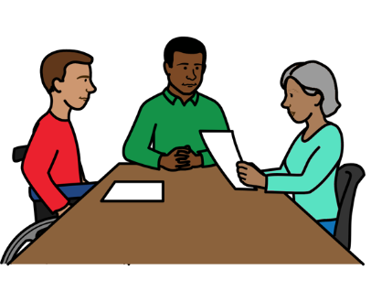
They will help us to do things like:

- Make sure our staff with disabilities get the right support and are treated fairly.

- Help more staff with disabilities to work for us.
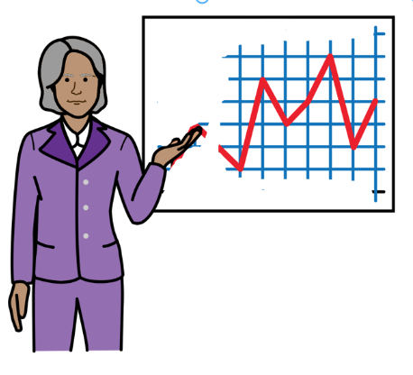
The new team will also help us to:

- Give our staff more training to know how to include people with disabilities.

- Make sure we have staff who know a lot about disability in each country we work in.

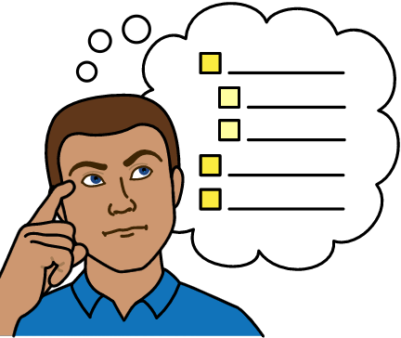

We will check every year how well we are doing to include people with disabilities.

We will set up some new groups of people to check on that.

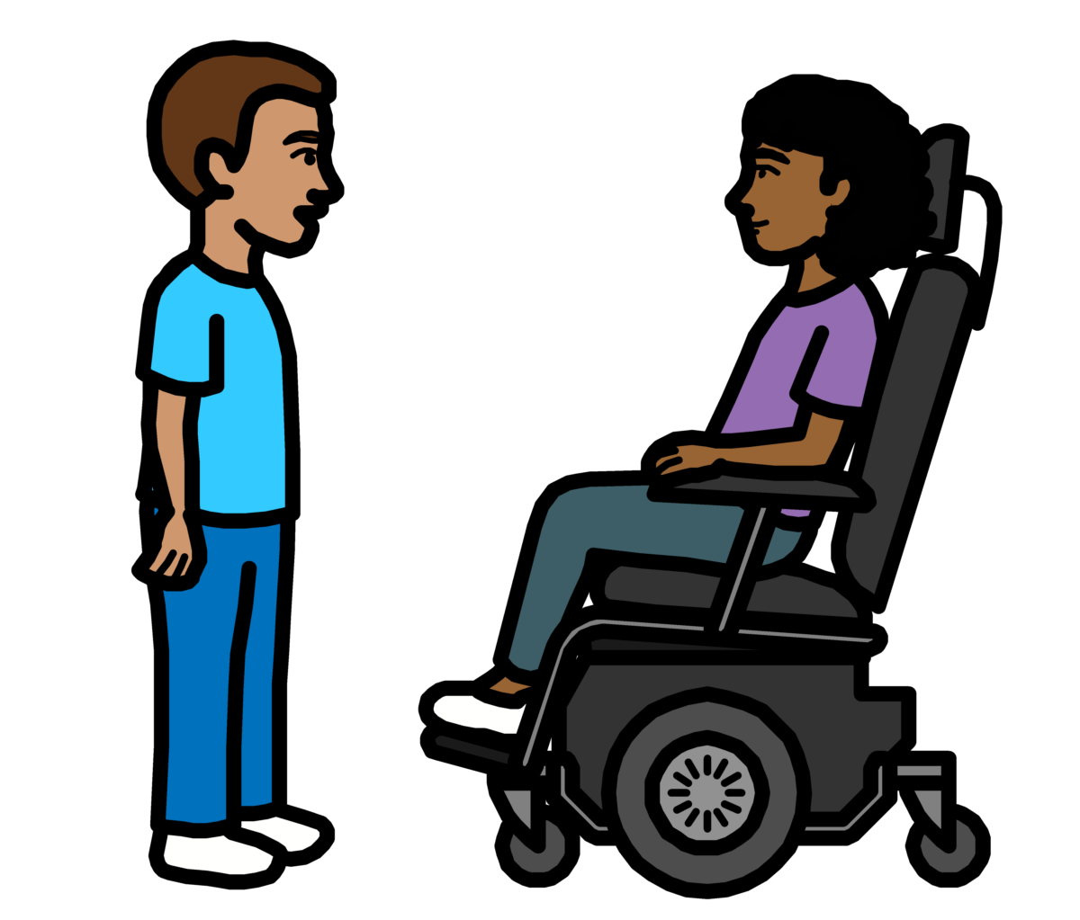

This plan will help us all to make sure that people with disabilities are never left out.

Pictures by The Picture Communication Symbols ©1981–2016 by Mayer-Johnson LLC a Tobii Dynavox company. All Rights Reserved Worldwide. Thousands of resources available for free at www.boardmakeronline.com

